[Create quiz ]

Technical Document

Date: 13/Feb/2019

Version: Version 0.1

# Table of Contents

Table of Contents 1

[Task Name] 2

Description 2

1.1 Mockup screen: 2

1.2 Angular & Spring Models 3

1.3 Angular Component 3

1.4 Rest Services 3

1.5 Flow Services: 4

1.6 Repository Functions 4

1.7 Database Script: 4

1.8 ER Diagram: 4

# 

# [Task Name]

Refer to: [Taiga URL]

## Description

Create quiz and add questions to it .

## Mockup screen:

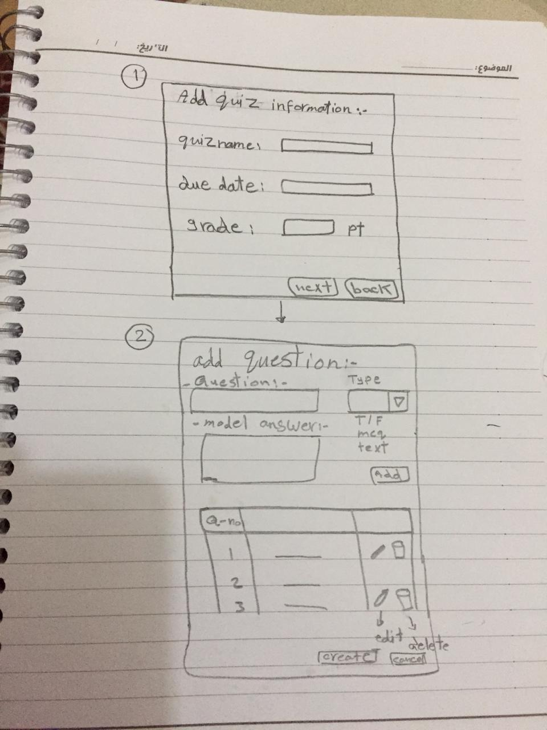

## Angular & Spring Models

|  |  |  |  |
| --- | --- | --- | --- |
| **New** | **Class Name** | QuestionType | |
| **Angular Path** | | app/modules/course/shared/data/question-type.ts | |
| **Spring Path** | | model/ QuestionType | |
| **Fields** | | | |
| **Attribute** | | **Angular Data Type** | **Spring Data Type** |
| id | | number | int |
| labelEN | | string | String |
| QuestionID | | number | int |

|  |  |  |  |
| --- | --- | --- | --- |
| **New** | **Class Name** | QuizInfoDTO | |
| **Angular Path** | | app/modules/course/shared/data/quiz-dto.ts | |
| **Spring Path** | | model/ QuizInfoDTO | |
| **Fields** | | | |
| **Attribute** | | **Angular Data Type** | **Spring Data Type** |
| id | | number | int |
| quizName | | string | String |
| questions | | question[] | List<Question > |
| grade | | number | int |
| dueDate | | DATE | Date |
| courseID | | number | int |

|  |  |  |  |
| --- | --- | --- | --- |
| **New** | **Class Name** | QuestionDTO | |
| **Angular Path** | | app/modules/course/shared/data/question-dto.ts | |
| **Spring Path** | | model/lookup/QuestionDTO | |
| **Fields** | | | |
| **Attribute** | | **Data Type** | **Spring Data Type** |
| id | | number | int |
| quiz_id | | number | int |
| question_type_id | | number | int |
| question | | string | String |
| modelAnswer | | string | String |
| answer1 | | string | String |
| answer2 | | string | String |
| answer3 | | string | String |
| answer4 | | string | String |

## Angular Component

|  |  |  |
| --- | --- | --- |
| **New** | **Class Name** | CreateQuiz |
| **Path** | | app/modules/course/components/create-course-details/create-quiz.component.[ts/html] |

|  |  |  |
| --- | --- | --- |
| **modify** | **Class Name** | CourseService |
| **Path** | | app/modules/course/shared/course.service.ts |
| **Function** | | createNewQuiz(quiz: quiz-dto)  addQuizQuestion(question: question-dto) |

## Rest Services

|  |  |  |  |  |  |  |  |
| --- | --- | --- | --- | --- | --- | --- | --- |
| **New** | **Name** | | api/quiz/createNewQuiz | | | **Method** | POST |
| **Controller** | | | QuizRes | | | **Function** | createNewQuiz(QuizInfoDTO) |
| **REST Parameter** | | | | | | | |
| **Attribute** | | **Parameter Type** | | **Data Type** | **Description** | | |
| quiz | | Payload | | QuizInfoDTO |  | | |

|  |  |  |  |  |  |  |  |
| --- | --- | --- | --- | --- | --- | --- | --- |
| **New** | **Name** | | api/quiz/getquestionsTypes | | | **Method** | GET |
| **Controller** | | | QuizRes | | | **Function** | getallQuestionsTypes() |
| **REST Parameter** | | | | | | | |
| **Attribute** | | **Parameter Type** | | **Data Type** | **Description** | | |
| N/A | | N/A | | N/A |  | | |

|  |  |  |  |  |  |  |  |
| --- | --- | --- | --- | --- | --- | --- | --- |
| **New** | **Name** | | api/quiz/addQuestions | | | **Method** | POST |
| **Controller** | | | QuizRes | | | **Function** | addQuizQuestions (QuestionDTO) |
| **REST Parameter** | | | | | | | |
| **Attribute** | | **Parameter Type** | | **Data Type** | **Description** | | |
| question | | Payload | | QuestionDTO |  | | |

## Flow Services:

|  |  |  |  |  |
| --- | --- | --- | --- | --- |
| **New** | **Class Name** | QuizSer | **Function** | createNewQuiz(QuizInfoDTO quiz) |
| **Description** | | Add New quiz | | |
| **Steps** | | | | |
| 1. Check if the user is Instructor 2. Validate quiz Data 3. Insert quiz Data in Database | | | | |

|  |  |  |  |  |
| --- | --- | --- | --- | --- |
| **New** | **Class Name** | QuizSer | **Function** | addQuizQuestion(QuestionDTO question) |
| **Description** | | Add quiz questions | | |
| **Steps** | | | | |
| 1-Insert question Data in Database | | | | |

|  |  |  |  |  |
| --- | --- | --- | --- | --- |
| **New** | **Class Name** | QuizSer | **Function** | getallQuestionsType() |
| **Description** | | Get available Types of the questions | | |
| **Steps** | | | | |
| 1. Select types of questions from database. | | | | |

## Repository Functions

|  |  |  |  |  |
| --- | --- | --- | --- | --- |
| **New** | **Class Name** | QuizRep | **Type** | Insert SQL |
| **Function** | | insertNewQuiz(QuizInfoDTO quiz) | | |
| **Query** | | | | |
| INSERT INTO quiz (quiz_name, due_date,grade ) VALUES (?, ?, ?) | | | | |

|  |  |  |  |  |
| --- | --- | --- | --- | --- |
| **New** | **Class Name** | QuizRep | **Type** | Insert SQL |
| **Function** | | insertNewQuestion(QuestionDTO question) | | |
| **Query** | | | | |
| INSERT INTO question (questionvalue, model answer ) VALUES (?, ?) | | | | |

|  |  |  |  |  |
| --- | --- | --- | --- | --- |
| **New** | **Name** | QuizRep | **Type** | Select SQL |
| **Function** | | getAllQuestionsTypes() | | |
| **Query** | | | | |
| SELECT * from quiz_questions_types ; | | | | |

## Database Script:

## ER Diagram:

